In some cases we will want to gather information about the conditions under which Survey is offered on a given TFN. For example, we may want to know what combinations of QT/CT/PT have survey enabled. To do this, there are a number of steps we need to complete. In the following example we will be using TFN 8777438734, which we have used in previous examples:

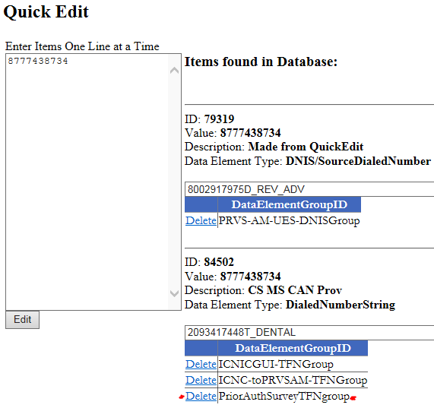

In *Quick Edit* in production Routing Services we can see that our TFN has the Data Element Group ‘*PriorAuthSurveyTFNgroup*’.

In Data Element Group Maps in production Routing Services can search for our Data Element Group to see what TFNs the group is mapped to:  
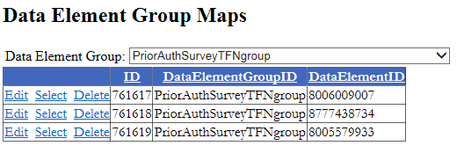

The next thing we want to discover is what *Route IDs* are assigned to this DataElementGroup. To do this we need to run our query ‘Data Route Map info’ connected to the Routing Services production server ‘dbsep1884cls’. Also, be sure to update the Data Element Group Name in the query relative to the Data Element Group we are working with:

  
To query this database you will need access to the global group *UHT_ICM_DBAccess* via Secure.

**Reading the Results**  
We can gather a large quantity of information from these results. The first thing we will look at is the *RteName* (route name) column of the results. This displays the dispatch app, in this case SAXC15. We can also see in the *ID* column the numerical ID of the entry in *Data Route Maps* in production Routing Services, in this case 16568.

With this information we can now open *Data Route Maps* in production Routing Services, select our dispatch app, then filter by ID and go through the entries until we get to 16568.



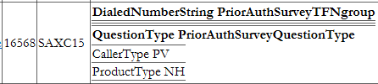

We can see that survey is offered on the three TFNs listed in the Data Element Group ‘*PriorAuthSurveyTFNgroup*’ where CT=PV, PT=NH and QT=’*PirorAuthSurveyQuestionType’*

This is another data element group that has been setup so we can check for more than one QT. In this case, both QT’s MD and DT will be checked for.

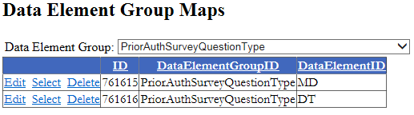

In cases where other IRV applications are involved, things will be more complicated.

In this example will be looking at TFN 8004459090 in routing services.

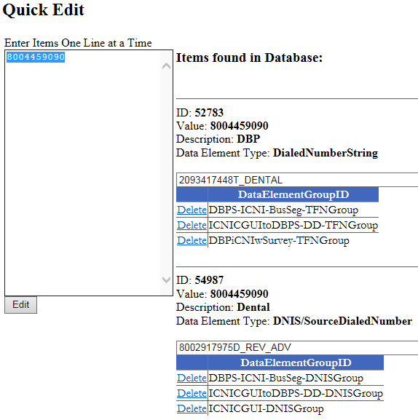

Looking at the three DataElementGroups assigned to this TFN, there are three mappings for this TFN. They indicate the TFN is in ICNI but also has routes to DBPS, which is the dental IVR.

**Data Element Group Breakdown**

1. DBPS-ICNI-BusSeg-TFNGroup (Dental from ICNIC)



I’m unsure what this mapping is, but I assume at this point it may be a link from Dental, back to ICNI, where that routing is required. (This will be updated after I can gather more information)

1. ICNICGUItoDBPS-DD-TFNGroup (ICNI to DD dental app)

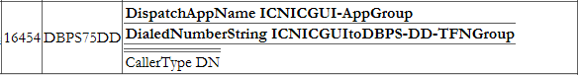

This mapping is for calls coming out of ICNI (indicated by ICNI as a dispatch app), that have CT=DT and are part of the ICNICGUItoDBPS-DD-TFNGroup. The TFNs in this group can be viewed in Data Element Group Maps in Routing Services:

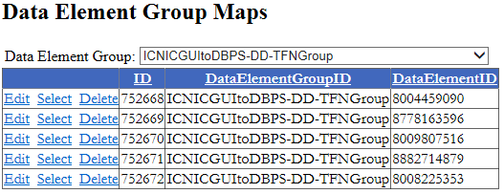

We can see our TFN in this group. This confirms that dental calls exiting ICNI from our TFN of 8004459090 will be routed to the Dental IVR app DBPS75DD.

1. DBPiCNIwSurvey-TFNGroup

The third mapping is a group of TFNs. Looking at these in Data Element Group Maps we can see that there are three pages of TFNs associated with this group.

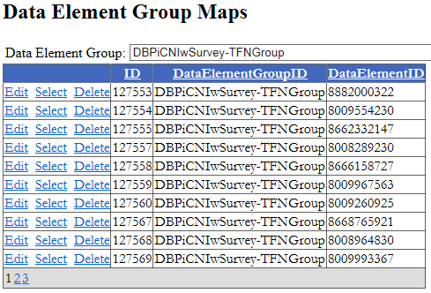

Running our query we can see that there are two Data Route Maps for this Data Element Group, the first of which sends calls for these TFNs to the ICNI app ICN22.



The second mapping, shown below for the survey app SAXC15 has 2 criteria. The first is our Data Element Group of TFNs and the second is that we are exiting ICNI.



**Routing Conflicts**

In our last example we were sending calls to the survey app where calls from our TFN were exiting ICNI. However, if they are also dental calls our previous mapping will take precedence and calls won’t be sent to the survey app. This is because Routing Services will always choose the route with the narrowest conditions.

